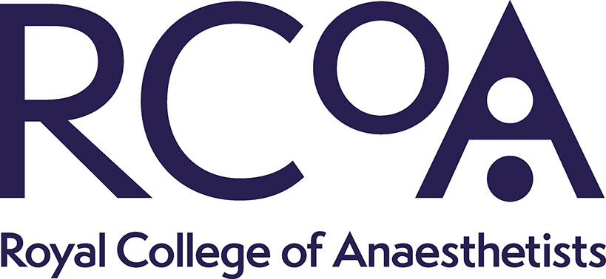

Anaesthesia and critical care COVID Activity survey (ACCC-track survey) round 1
Executive Summary

Thanks
First and foremost, many thanks to all local co-ordinators and their teams who returned data for this survey. At such short notice, in a pandemic, a 64% return rate is a credit to you all. We attach a slide set summarising key results - please present or disseminate to your department. We have results to anaesthesia-surgical activity and workforce in NHS hospitals for the time being. We are equally grateful to those responded from the independent sector and we will report these data later.

Results
The results are from October and represent response before lockdown started. The top lines are
- An excellent 2/3 response rate (but we would like to do better in round 2).
- Around a third of hospitals were struggling to function (orange) or unable to function normally (red) with staff and space being the greatest challenges. Fewer than half of all hospitals were functioning adequately (green) with all of staff, space, stuff and systems.
- 1 in 6 operating theatres is closed – rising to almost half of theatres in one region.
- Ten percent additional surgical capacity has been created by use of the independent sector and this affects all regions.
- More than half of all hospitals (and >70% in most regions) are using external sites to support their ‘lower COVID-19 risk’ surgery.
- In theatres that are open, productivity is significantly affected, with almost half reporting running at <75% of normal activity levels.
- By hospital, the impact on surgical specialties is greatest for paediatrics, followed by non-cancer surgery then emergencies. Paediatrics – 59% of normal activity – may be impacted by relocation of paediatric surgery to specialist paediatric centres. Cancer surgery is down 26%.
- Overall, we estimated surgical activity is reduced by 27% compared to the same time last year. This is equivalent to almost 5000 operations not taking place each day. While if extended over a year, this would equate to a loss of approximately 1 million NHS operations.
- As we know, anaesthetists are resilient and sickness rates are low. However, including all clinicians away from patient-facing anaesthetic work (due to shielding, COVID-19 related sickness, self-isolation or quarantine) and due to redeployment to ICU we estimate that anaesthetic departments have 7% fewer staff. The majority of these absences are due to staff redeployed to ICU, where full time staffing levels have been increased by approximately 23%.

Round 2 – coming this week
We are very keen to get on with round two – this will be sent out this week and will be shorter than round 1!
Please do take part even if you were not able to send a response to round 1. We are particularly keen that those hospitals in areas of high COVID-19 activity respond as return rates were slightly lower from these areas.

Many thanks and keep safe.

Emira Kursumovic, Tim Cook, Jas Soar on behalf of the ACCC-Track team

